# Connecting to Shard1 primary node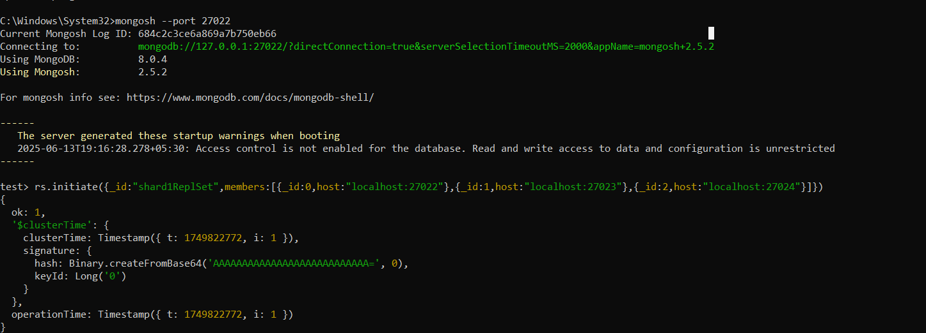

# Connecting to Shard2 primary node

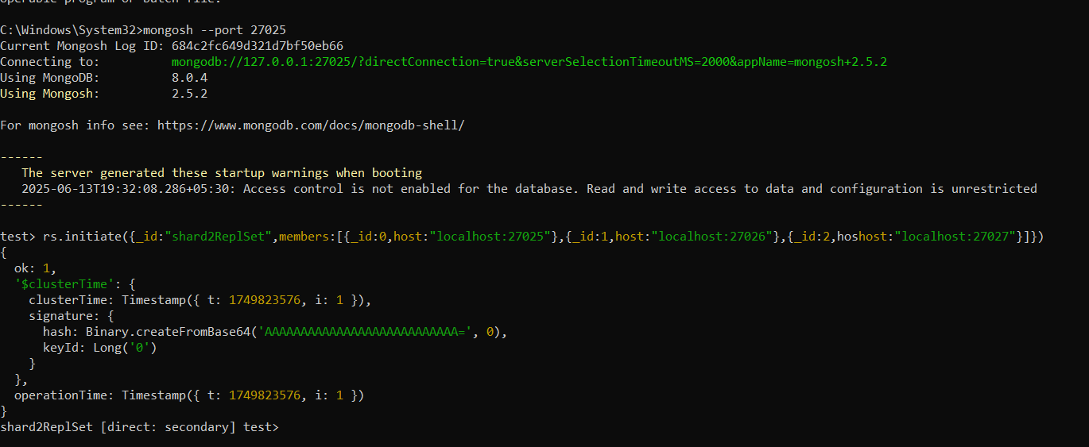

# Connecting to mongos router

# Adding Shard1 to cluster

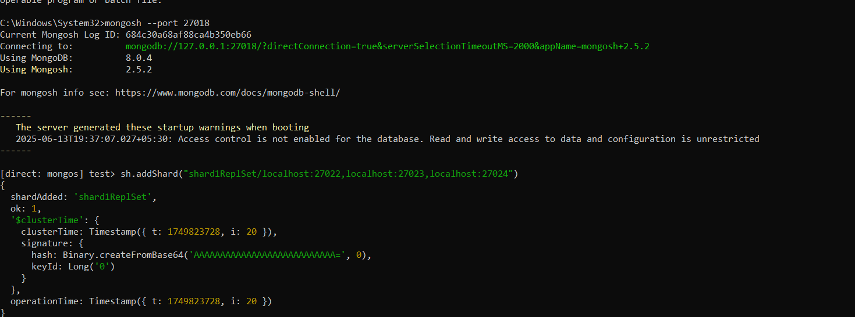

# Adding Shard2 to cluster

# Enabling sharding on testDB

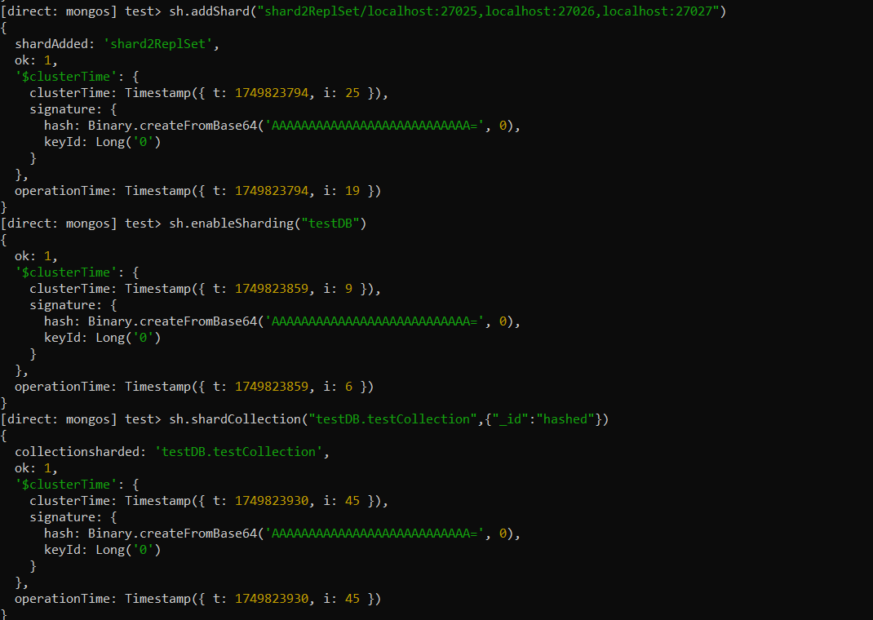

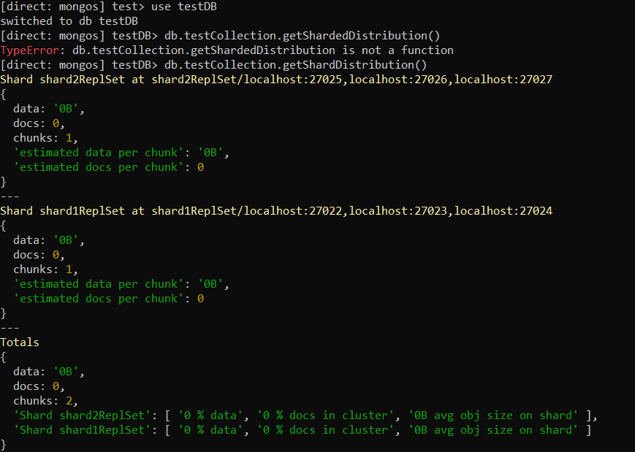

# Inserting 10,000 documents into testCollection

# Checking shard distribution after data insertion

